18. BE CER Compliance for Log360

**Tagline** – Meet Belgium's CER Directive obligations with real-time monitoring from Log360.

**Overview**
The BE CER Compliance extension for Log360 helps Belgian organizations maintain full compliance with Critical Entity Registry requirements. By integrating this extension, IT and security teams gain comprehensive visibility into their critical entity security posture and control effectiveness.
Log360 continuously collects and correlates log data from Active Directory, Windows, Unix/Linux, Microsoft 365, cloud platforms, and network devices, mapping events directly to CER requirements. Security teams can track compliance status in real time, investigate incidents quickly, and generate audit-ready reports with a single click.

**Key Features:**
- Generate comprehensive audit-reports mapped to all BE CER critical entity security controls and requirements.
- Correlates logs from different sources to detect threats, anomalies, and suspicious activities affecting critical systems.
- Generates real-time alerts for critical CER events with multi-channel notifications to security teams.
- Export reports in PDF and CSV format for auditors, management, or regulatory submissions.


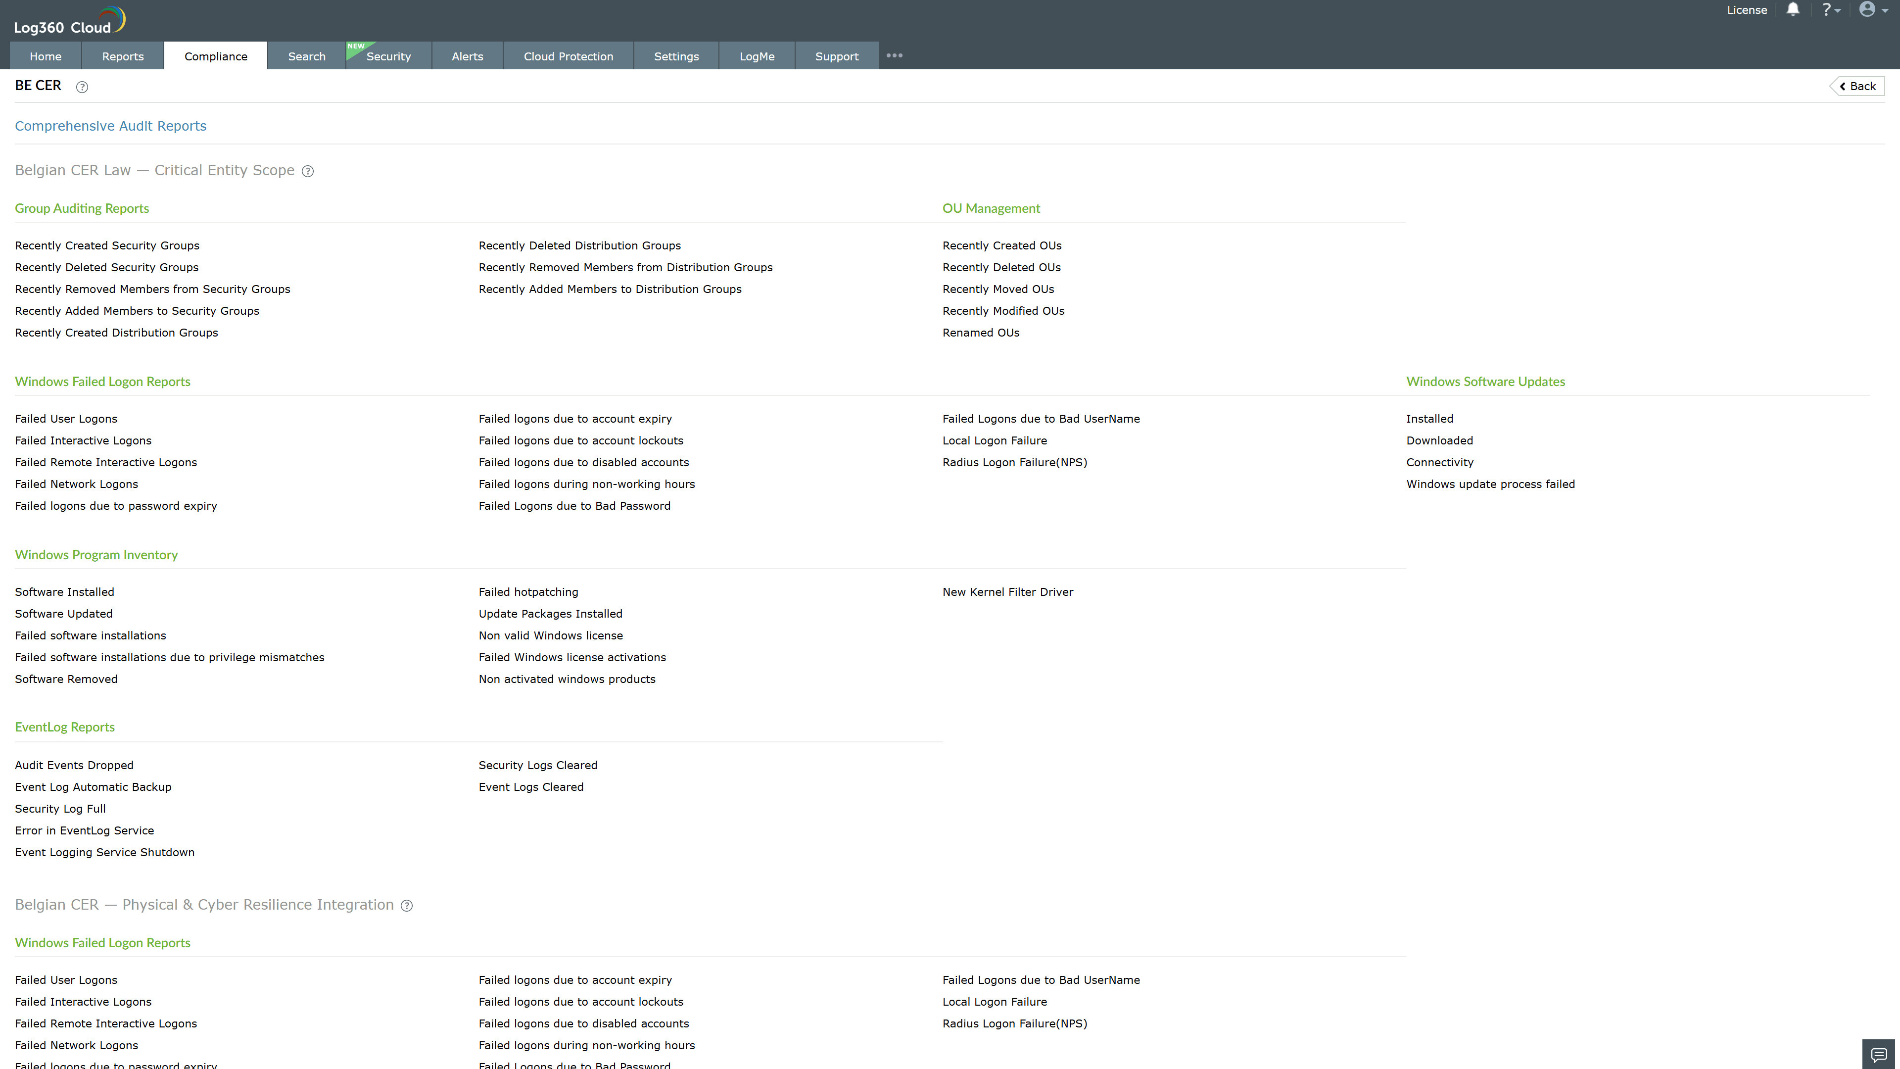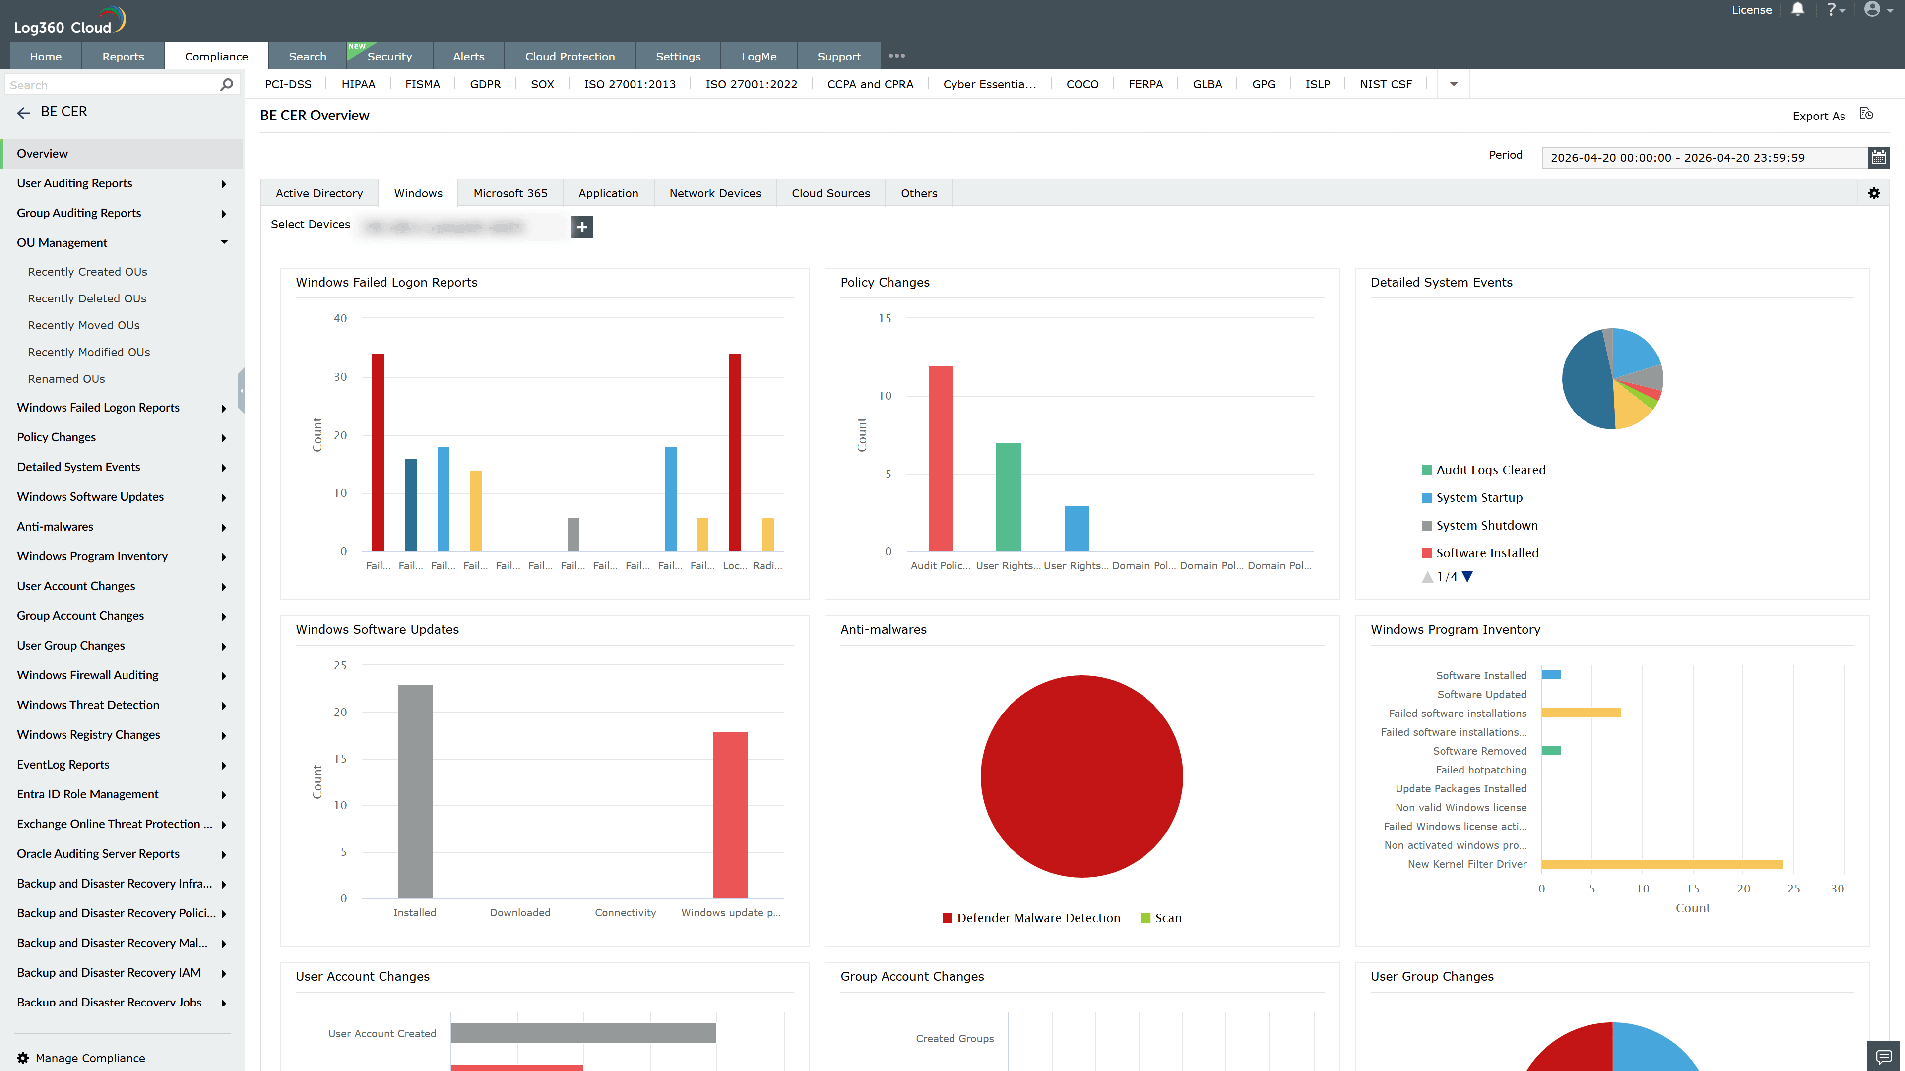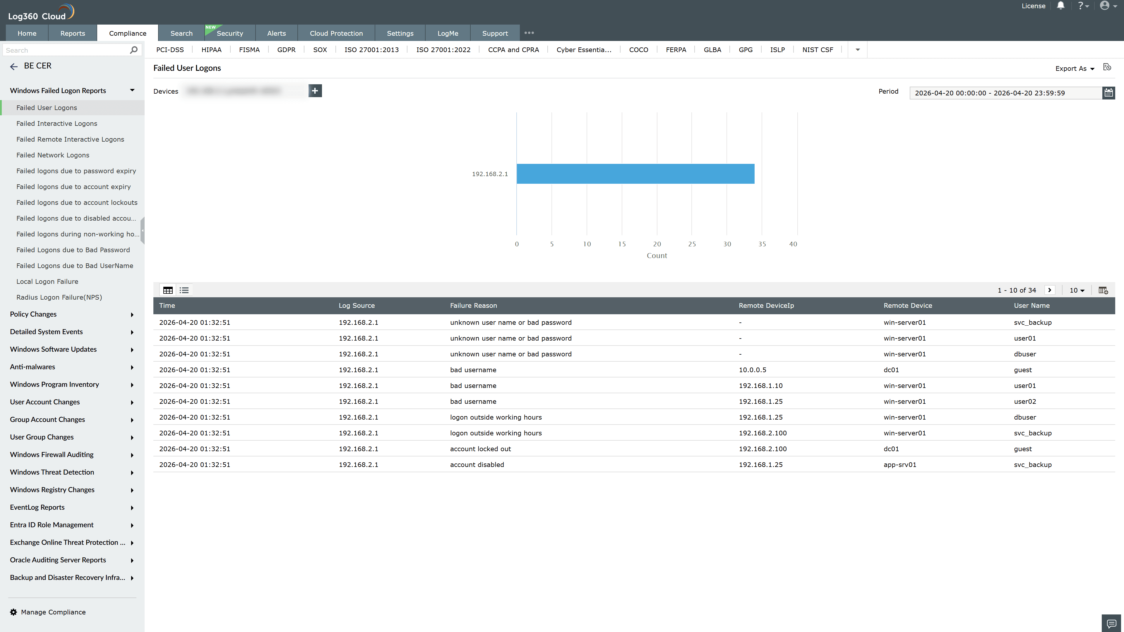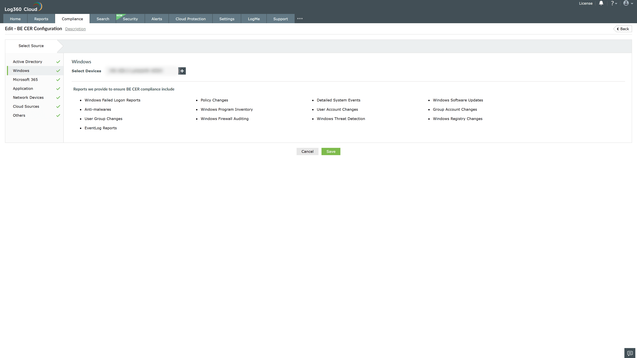
Valid Submission : Yes
Supported Editions : Free, Basic, Standard, Professional, MSSP
Help Document : https://www.manageengine.com/log-management/help/integrations/compliance-extensions.html
Help Video : Not provided
Tags : Log360, Compliance, Privacy monitoring, Data privacy, Regulatory compliance
Supported DCs : US, IN, JP, CA, AU, UK and EU
Privacy Policy:
Terms of Service:
Release Notes:
Predefined reports for the BE CER Compliance.

